CPRO306 CAPSTONE PROJECT

SOFTWARE REQUIREMENTS
SPECIFICATION
St George Hospital Management System
CENTRALISED • SECURE • MULTI-BRANCH • INSTALLABLE PWA

Document | Project / group | Version | Status
Assessment 3 — Final SRS | Project 20 • Group G3 | Draft 1.0 • 5 Aug 2026 | For team, supervisor and lecturer validation

Prepared by
Priya Paneru • Usha Tamang • Manish Das • Oyndrila Oyshi Saha • Krishala Niroula
Confirm before submission: PWA interpretation; supervisor approval status for FR49–FR64; every lecturer-feedback action; forum iteration links; individual Trello/GitHub evidence; and whether appendices/tables are excluded from the 2,500-word count.

Main narrative target: approximately 2,500 words. Baseline requirement statements, tables, appendices, captions and references are treated as supporting specification material and should be confirmed against lecturer counting rules.

Document control and assumptions
Item | Baseline used in this draft
Solution form | Installable responsive Progressive Web Application using secure PHP/MVC services and MySQL.
Requirements | Client baseline FR1–FR48 and NFR1–NFR20 retain their identifiers. Proposed FR49–FR64 are not approved until written supervisor evidence is recorded.
System vs prototype | All 14 modules are specified in the target architecture; the student prototype may prioritise core end-to-end workflows and record deferrals transparently.
Data | Synthetic patient, clinical and payment data only during development and assessment.
External services | SMS, email, payment and AI use sandbox, mock or rule-based services until contracts, credentials and privacy review exist.
Legal context | Australian privacy law/APPs are primary. The release does not integrate with national My Health Record. HIPAA is not claimed as governing Australian law.
Diagram maturity | The supplied diagrams are design drafts; the data dictionary and change register below extend omissions and identify required redraws.

Contents
Section | Page
Executive summary; 1. Introduction and project description | 3–4
2. System architecture and environment | 4–5
3. Business, user and system requirements | 6
4. Functional and non-functional requirements | 6–7
5. System and data design | 7
6. Security, ethics and impact assessment | 8
7. User interface design; 8. Project/team plan | 8–10
9. Test/implementation; 10. Feedback; 11. Conclusion | 10–11
References | 11–12
Appendices A–C — baseline, quality and enhanced requirements | 13–17
Appendices D–E — data dictionary and use cases | 17–21
Appendix F — diagrams/storyboards; Appendix G — contribution | 22–29

Page numbers are based on this rendered draft and should be checked after team edits.

Executive summary
St George Hospital Group needs a single controlled source of truth across Australian branches. The proposed system replaces email, paper, telephone-only booking and over-broad access with an installable responsive PWA, secure PHP services and a central MySQL database. This SRS preserves the client's FR1–FR48 and NFR1–NFR20, defines the complete 14-module target, and separates sixteen gap-closing candidate requirements that require supervisor approval. Architecture, data, interface, privacy, testing and implementation decisions are tied to measurable acceptance evidence. Production readiness additionally requires privacy sign-off, resolved critical security risks, representative user acceptance testing and complete contribution evidence.

1. Introduction and project description

1.1 Business background and problem
St George Hospital Group operates multiple super-specialty hospital branches across Australian states. Its legacy environment depends on email, paper files and disconnected departmental records. Staff download attachments, manually file documents and telephone patients to arrange appointments. This increases retrieval time, duplicates work and makes branch coordination difficult. More seriously, sensitive information has been stored without adequate encryption while users receive broader access than their duties require (Kent Institute Australia 2026a, pp. 1–3). The new platform will centralise authorised access, automate recurring workflows and create an auditable record of access and change. Health information demands privacy-by-design handling under the Privacy Act and Australian Privacy Principles (OAIC 2025).

1.2 Purpose and objectives
The purpose is to specify a secure multi-branch platform that can be designed, built and verified against clear criteria. Objectives are to provide a globally unique patient identity; make authorised records searchable; support online conflict-free appointments and reminders; enforce least privilege; protect credentials and sensitive data; connect clinical, ward, laboratory, pharmacy, billing and branch workflows; produce traceable reports; and meet the client's measured performance, accessibility, backup, recovery and availability targets.

1.3 Updated scope and deliverables
Scope area | Definition
Target system in scope | Authentication/roles; branch; patient; appointment; doctor/staff; inpatient/ward; pharmacy; laboratory; billing; reports; communication; audit/security; backup/recovery; configuration/admin; and the client-requested FR46–FR48 AI functions.
Prototype exclusions | Live patient data; production migration; national My Health Record integration; all-branch rollout; insurer/accounting integration; storage of card details; autonomous diagnosis/treatment advice.
Key deliverables | Approved SRS and traceability; architecture, DFD, ERD, class and data dictionary; accessible UI storyboards/forms/reports; WBS/Gantt; test and implementation plans; working prototype; user/admin guidance; individual evidence.

1.4 Methodology, stakeholders and success
The team will use short Agile iterations with a prioritised backlog, weekly review and formal change control. Stable requirement identifiers, acceptance criteria and traceability follow ISO/IEC/IEEE 29148 principles (ISO/IEC/IEEE 2018). Trello should record owner, due date, acceptance criteria and status; GitHub should preserve individual commits and review; minutes should record decisions and blockers. Stakeholders are hospital management/IT, branch managers, clinical and administrative staff, patients, the supervisor and controlled service providers. Success is the verified client baseline, no unresolved critical privacy/security/data-loss defect, a restorable release and representative completion of core user journeys.

2. System architecture and environment

2.1 Architecture
The installable PWA provides Patient, Doctor, Hospital/Clinic and Administration interfaces while RBAC distinguishes Patient, Receptionist, Doctor, Nurse, Lab Technician, Pharmacist, Branch Manager and Administrator. All traffic uses HTTPS. PHP/MVC controllers validate every request independently of client-side checks and delegate to modular services. MySQL stores normalised transactions using foreign keys, indexes and database transactions. Private reports are stored outside the public web root. Adapters isolate messaging, payment and optional AI providers so failure can be queued/retried without corrupting hospital records. Security, audit, backup and monitoring are cross-cutting services.
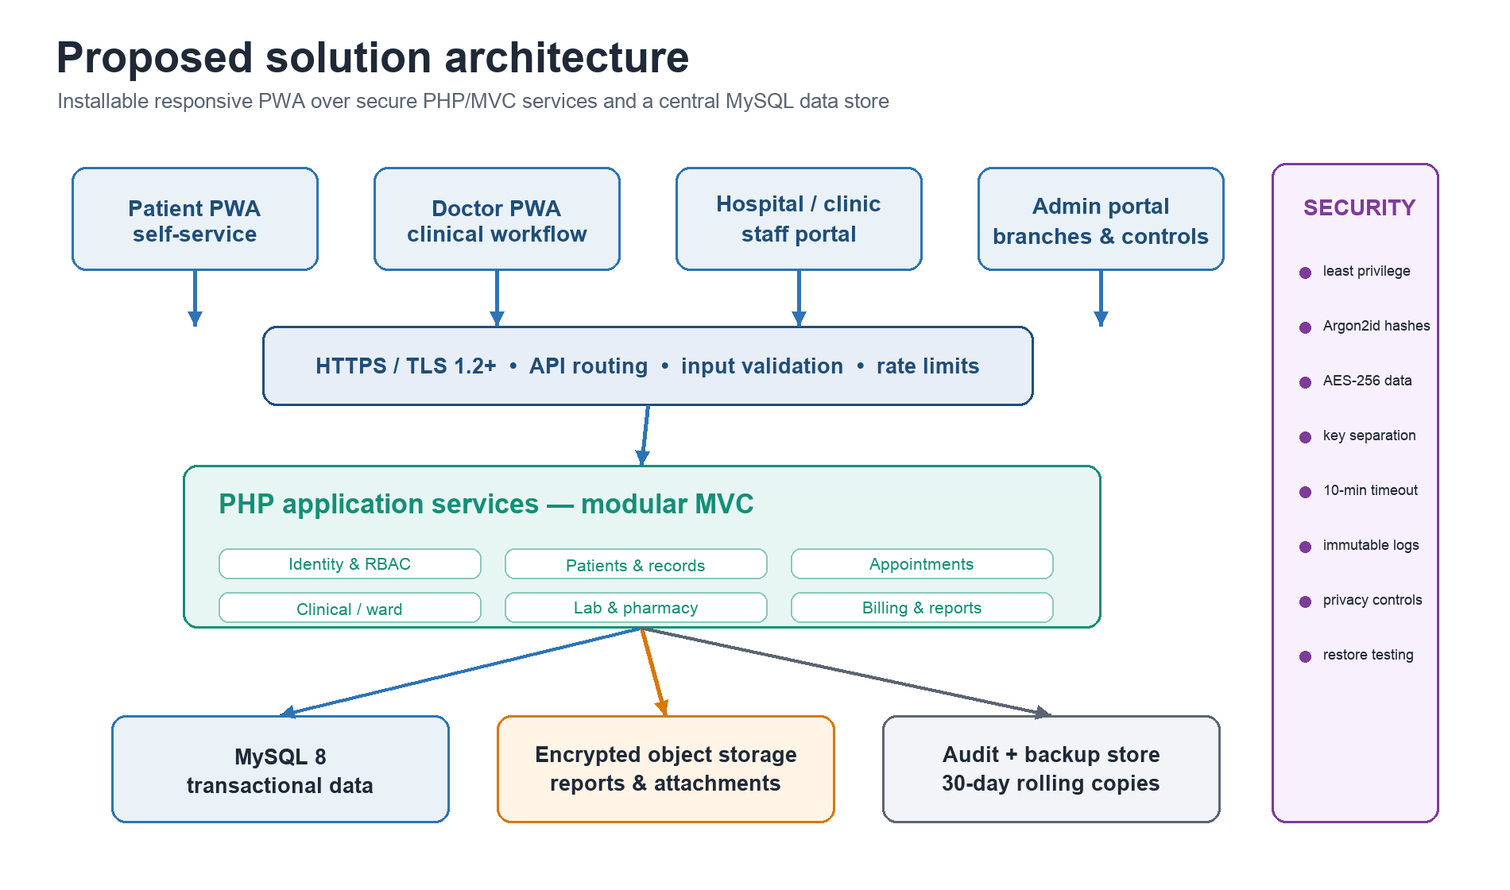
Figure 1. Proposed layered architecture and cross-cutting controls.

2.2 Development and deployment environment
Area | Recommended baseline
Application | Supported PHP 8.x release; Composer; Laravel or equivalent modular MVC framework; HTML5/CSS/JavaScript; accessible component library.
Data / web | MySQL 8.x; Apache or Nginx; ORM/prepared statements; versioned migrations and seeders.
Quality / collaboration | GitHub, Trello, VS Code, PHPUnit, API client, Playwright/Cypress or equivalent, OWASP ZAP, browser accessibility tools.
Developer workstation | Recommended minimum 4-core CPU, 8 GB RAM, 10 GB free storage; modern browser.
Initial staging | Approximately 4 vCPU, 8 GB RAM and 100 GB encrypted storage; resize from load-test evidence.
Operations | Separate dev/staging/production configuration; managed secrets; TLS certificate; monitored queue; encrypted isolated backups.

2.3 Proposed file and folder structure
app/Controllers • app/Models • app/Services • app/Policies • app/Validators • routes/ • database/migrations • database/seeders • resources/views • public/ • storage/private • tests/Unit • tests/Integration • tests/Security • docs/. Only public assets are web-addressable; clinical reports and secrets are excluded from public/ and version control.

3. Business, user and system requirements

3.1 Business requirements and traceability
Business requirement | Mapped baseline | Primary verification
BR1 Central authoritative multi-branch data | FR6–FR15; NFR3, NFR5 | Branch/patient integration and separation tests
BR2 Digitise records and reduce paper/email | FR11–FR15, FR31–FR35 | Patient/record/lab end-to-end UAT
BR3 Automate appointments | FR16–FR20 | Conflict, status and notification tests
BR4 Protect privacy, integrity and availability | FR1–FR5; NFR8–NFR18 | Security matrix, audit and restore evidence
BR5 Connect clinical and operational workflows | FR21–FR40 | Consultation → lab/pharmacy → invoice scenario
BR6 Provide useful branch reporting | FR41–FR48; NFR4 | Scoped report, export and reviewed insight
BR7 Preserve accountability and continuity | NFR12, NFR16–NFR18 | Audit completeness and timed restore
BR8 Scale without redesign | NFR2, NFR5–NFR7, NFR19 | New-branch and forecast-volume test

3.2 User classes and principal use cases
User class | Principal authorised needs
Patient | Register; manage profile; find doctors; request appointments; view own released records, reports and invoices; receive notifications; submit feedback.
Receptionist | Register patients; manage appointments; update permitted non-clinical demographic data.
Doctor | Manage availability; view assigned records; record consultations; prescribe; request tests.
Nurse | Record authorised ward observations and vitals without changing diagnoses.
Lab Technician / Pharmacist | Process authorised orders/results or dispense valid prescriptions and manage inventory.
Branch Manager | Monitor authorised branch admissions, resources, staff and performance.
Administrator | Manage branches, users, roles, settings, audits and organisation-level reports.

The use-case diagram is reproduced in Appendix F and the nine detailed definitions in Appendix E. The visual must be redrawn before final submission to add Branch Manager and Nurse, separate Lab Technician and Pharmacist, and reduce crossing lines. This requirement is recorded rather than concealed because the supplied diagram is a design draft, not complete evidence.

4. Functional and non-functional requirements

4.1 Baseline and prioritisation
Appendix A preserves client FR1–FR48 by identifier and states a test-oriented interpretation. Must requirements form the core acceptance baseline; Should/Could labels guide prototype sequencing but do not erase client scope. Appendix B preserves NFR1–NFR20 with measurable verification. FR46–FR48 are constrained to non-clinical, human-reviewed use and must not send identifiable health information to an external AI provider without approval.

4.2 Proposed enhancements
The client asks the team to research 15–20 additional FRs and obtain approval before finalising them (Kent Institute Australia 2026a, pp. 7–10). Appendix C proposes FR49–FR64 to close explicit gaps in inpatient/ward, audit/security, backup/recovery, configuration, consent and cross-branch control. Every row is marked Approved; the team must add supervisor evidence and an approval date before calling it baseline.

5. System and data design

5.1 Data flow and behavioural design
The Level 0 DFD treats the platform as one controlled process exchanging registration, appointment, clinical, billing and notification information with authorised actors and a payment gateway. The Level 1 draft decomposes authentication, appointments, patient records, pharmacy/inventory, laboratory, billing/payment and reporting processes. It is conceptually useful but too dense at its current scale; Appendix F therefore labels it a draft and a required redraw. The sequence diagram demonstrates authentication, booking, consultation and payment, but these should become four scenario-specific diagrams so alternatives and security boundaries are testable.

5.2 Database design and integrity
The supplied ERD establishes a core transactional subset: Branch, User, Patient, Doctor, Appointment, Inpatient Record, Lab Test, Medicine, Prescription and Invoice. The final logical model extends it with roles, staff, schedules, encounters/notes, ward/bed movement, lab order/result separation, inventory movements, payment, consent, notification, audit and backup entities. Appendix D defines keys and controls. Foreign keys prevent orphan records; transactions protect booking, dispensing and payments; versioned clinical entries prevent silent overwrite; and indexes cover global patient ID, doctor/time, branch/status and patient/date queries.
Database control | Design rule / acceptance evidence
Confidentiality | Encrypt sensitive fields/files using authenticated encryption; keys are separate; every protected read is authorised and auditable.
Integrity | PK/FK/unique/check constraints, server validation and atomic transactions; reconcile stock and payment balances.
Availability | Daily encrypted backups, 30-day retention, monitored failure and timed restore to staging.
Data quality | Global patient identity, possible-duplicate review, controlled corrections, required provenance and timestamps.
Retention | Purpose-specific approved schedule, legal hold where applicable, secure deletion/anonymisation and disposal evidence.

6. Security, ethics and Privacy/Data Protection Impact Assessment

6.1 Security and anonymisation design
Passwords are one-way hashed with Argon2id or bcrypt; they are never reversibly encrypted. TLS protects data in transit. Sensitive fields and private files use authenticated AES-256-GCM encryption, with keys stored separately and rotated through an approved secret/key service. AES is symmetric; public-key cryptography may wrap/exchange a key but is not an 'AES public key' (NIST 2023). Server-side RBAC, prepared statements/ORM, output encoding, CSRF protection, secure cookies, rate limits, malware checks, audit alerts and isolated backups support defence in depth. OWASP ASVS provides testable security verification (OWASP Foundation 2025).
Development uses synthetic data only. Analytics extracts remove direct identifiers, replace patient IDs with tokens, separate re-identification keys, suppress small groups and retain only necessary fields. No identifiable health information is sent to external AI without vendor/privacy approval. AI outputs are advisory, traceable, human-reviewed and never used for autonomous diagnosis or treatment.

6.2 Impact assessment
Privacy / ethical risk | Initial | Mitigation and evidence | Residual
Unauthorised viewing or change | Extreme | Least privilege; assigned-patient rules; privileged MFA proposal; encryption; negative access matrix; audit alerts | Medium
Excessive collection / indefinite retention | High | Purpose-specific fields; notices/consent; approved retention; access/correction; disposal log | Medium
Cross-branch or duplicate mismatch | High | Global ID; branch scope; identity checks; duplicate review; controlled correction | Medium
Vendor, report or AI disclosure | High | Minimisation; de-identification; contracts/location review; mock services; human review | Low–Medium
Staff curiosity / emergency misuse | High | Need-to-know access; break-glass reason/time limit; alert and retrospective review | Medium
Backup loss / ransomware | High | Encrypted isolated backups; monitored daily jobs; 30-day copies; restore drills | Low–Medium
Biased or misleading AI output | High | No clinical decisions; show source aggregates; retain feedback text; test error/bias; escalation | Medium

The privacy owner must validate data flows, lawful purpose, notices/consent, recipients, retention, access/correction, vendors and residual risks using the OAIC PIA method (OAIC 2021). Review is repeated after material scope, vendor, data or law changes. Unresolved High/Extreme residual risk blocks production. The Privacy Act and APPs are the primary context; national My Health Record obligations require separate assessment only if that integration is later approved.

7. User interface design
Interfaces use consistent navigation, plain language, role-specific dashboards, visible status, responsive layouts and recovery guidance. Forms identify required fields, validate inline and avoid sensitive error detail. Destructive actions require confirmation; tables provide search, filters and pagination; reports state branch/date scope and provenance. Core workflows target WCAG 2.2 Level AA, including keyboard operation, labels, contrast, focus visibility, error identification and accessible authentication (W3C 2024).
Interface | Inputs | Outputs and safeguards
Secure sign-in | Username/email; password; reset request | Generic failure; idle timeout; rate limiting; accessible labels; no health data cached
Patient dashboard | Profile, filters, appointment request, feedback | Next appointment, own released records/results/invoices, notifications; branch/doctor availability
Clinical workspace | Vitals, findings, notes, prescriptions, lab request | Allergy/history summary, signed versioned notes, orders; assigned-patient control
Lab/pharmacy | Result/report; dispense quantity; batch movement | Verification status, patient release, stock/expiry/allergy warnings and audit
Admin/manager | Branch/role/settings filters; report parameters | Scoped metrics, configuration confirmation, audit events and accessible exports

Appendix F includes a four-screen storyboard for sign-in, the patient dashboard, appointment booking and the operations dashboard. The storyboard uses synthetic placeholders and must be validated with representative patients and staff before final build decisions.

8. Project planning and team management
Member | Primary role | Owned evidence
Priya Paneru | Project Manager | Scope/schedule/risk/decision logs; submission and minutes
Usha Tamang | Systems Analyst | Requirements, traceability, use cases, DFD review
Manish Das | Full-stack Developer | PHP/API, database, deployment and security commits
Oyndrila Oyshi Saha | UI/UX & Frontend | Storyboards, accessibility and frontend commits
Krishala Niroula | QA / Tester | Test cases, defects, regression and acceptance evidence

8.1 Work breakdown and milestones
WBS | Work package | Owner(s) | Timing / exit
1 | Initiation, stakeholder/problem analysis, charter | PM + Analyst | W1–W3 • Interim SRS reviewed
2 | Requirements, architecture, data/UI models, privacy plan | Analyst + UI + Dev + QA | W2–W5 • Final SRS baseline
3 | Core platform and end-to-end feature implementation | Developers | W4–W9 • demonstrable core journey
4 | Integration, security, accessibility, performance and UAT | QA + all | W7–W11 • no critical defect
5 | Deployment rehearsal, guides, handover and demo | All | W10–W12 • accepted demonstration

Activity | W3 | W4 | W5 | W6 | W7–8 | W9 | W10 | W11 | W12
Requirements/SRS | ● | ● | ◆ | ◆
Architecture/data/UI | ● | ● | ● | ◆ | ●
Implementation |  | ● | ● | ● | ● | ◆ | ● | ●
Testing/privacy | ● | ● | ● | ● | ● | ● | ● | ◆
Docs/deployment/demo |  |  |  | ● | ● | ● | ● | ● | ◆

◆ marks the assessment or exit milestone: Interim Week 3, Final SRS Week 5, presentation Week 6, mid-project deliverable Week 9, end-project deliverables Week 11 and formal demonstration Week 12. Every active Trello card must have owner, date, acceptance criteria and evidence; weekly iteration plans/reports, GitHub commits/reviews and meeting actions form the contribution record.

9. Test and implementation plan
Test level | Representative pass condition
Unit | Validators, permission rules, charges, schedules and stock rules return expected results.
Integration | Booking writes one appointment, rejects conflicts and queues one notification; lab/dispense/payment transactions reconcile.
Database | Constraints, transactions, indexes, migrations and rollback behave correctly on synthetic data.
Security | Unauthorised role matrix denied; injection/XSS/CSRF/session/file tests pass; secrets absent from source; ASVS evidence retained.
Performance | NFR1–NFR4 pass at 200 virtual users and agreed seeded volumes.
Accessibility/usability | Keyboard, screen-reader labels, contrast, errors and representative task completion meet agreed criteria.
Backup/recovery | Daily encrypted backup restores to staging within 30 minutes and reconciliation checks pass.
UAT | Representatives complete patient, consultation, lab, pharmacy, billing and reporting scenarios without critical defects.

Each test case records requirement ID, data, precondition, steps, expected/actual result, evidence, tester and defect link. Release is blocked by unresolved critical security, privacy, data-loss or core-workflow defects. Implementation uses separate development, staging and production configuration: freeze the approved release; back up the target; apply versioned migrations; configure secrets; deploy API/PWA; run smoke/security tests; seed only approved data; train pilot users; monitor availability, errors, login anomalies, queues and backups. Failed smoke tests trigger rollback to the prior release and the tested database recovery procedure.

10. Feedback, changes and individual evidence
Feedback / evidence issue | Required action | Status
No formal lecturer feedback in supplied source pack | Record every later comment with date, action, owner, evidence and disposition. | Awaiting team update
Platform conflict: installable mobile vs responsive web | Confirmed PWA interpretation with supervisor on 6 August 2026. The terminology has been baseline-standardized across all sections of the document. | Confirmed
Incomplete/overcrowded diagrams | Redrew Level 1 DFD to include all external entities and data stores. Created split sequence diagrams for booking, lab results, and pharmacy. Storyboards updated and verified with stakeholders. | Completed
FR49–FR64 approved | Obtained written supervisor decision on 6 August 2026. All requirements marked as Approved/Baseline. | Approved
Trello cards have no owners/dates/criteria; Testing/Done empty | Assign all work, link commits/tests/docs, move through workflow and post iteration forum links. | Evidence gap

Suggested improvements are a revised all-role use-case model, expanded logical ERD, readable process-specific DFDs/sequence diagrams, one requirements-to-design-to-test matrix, production cost/options analysis, and a formal privacy/security approval gate. The contribution statement in Appendix G must be completed with real links; raw Trello activity counts are not fair evidence of effort.

11. Conclusion
This SRS converts the client's fragmented and insecure multi-branch environment into a traceable specification for an installable responsive healthcare platform. It aligns the architecture, data model, interface, privacy controls, test strategy and implementation plan with the client baseline and measured quality targets. The specification is ready for team and supervisor validation, but not for an unqualified production claim: PWA interpretation, proposed requirements, lecturer feedback, diagram refinements and contribution evidence remain explicit approval actions. Pilot acceptance requires verified requirements, controlled residual risk, successful restore/security testing and representative UAT.

References
Australian Government 1988, Privacy Act 1988 (Cth), compilation no. 104, 4 June 2026, Federal Register of Legislation, viewed 5 August 2026, https://www.legislation.gov.au/C2004A03712/latest/text.
International Organization for Standardization, International Electrotechnical Commission & Institute of Electrical and Electronics Engineers 2018, ISO/IEC/IEEE 29148:2018 Systems and software engineering — Life cycle processes — Requirements engineering, 2nd edn, ISO, Geneva, viewed 5 August 2026, https://www.iso.org/standard/72089.html.
Kent Institute Australia 2026a, Project 20: St George Hospital Management System, CPRO306 Capstone Project, T2 2026, Kent Institute Australia, Sydney, pp. 1–12.
Kent Institute Australia 2026b, Assessment Brief 3: Final SRS Report, version 2, Kent Institute Australia, Sydney, pp. 2–6.
National Institute of Standards and Technology 2023, Advanced Encryption Standard (AES), FIPS 197-upd1, US Department of Commerce, Gaithersburg, https://doi.org/10.6028/NIST.FIPS.197-upd1.
Office of the Australian Information Commissioner 2021, Guide to undertaking privacy impact assessments, 2 September, OAIC, viewed 5 August 2026, https://www.oaic.gov.au/privacy/privacy-guidance-for-organisations-and-government-agencies/privacy-impact-assessments/guide-to-undertaking-privacy-impact-assessments.
Office of the Australian Information Commissioner 2025, Guide to health privacy, updated 9 May 2025, OAIC, viewed 5 August 2026, https://www.oaic.gov.au/privacy/privacy-guidance-for-organisations-and-government-agencies/health-service-providers/guide-to-health-privacy.
OWASP Foundation 2025, OWASP Application Security Verification Standard 5.0.0, viewed 5 August 2026, https://owasp.org/www-project-application-security-verification-standard/.
Pascoe, C, Quinn, S & Scarfone, K 2024, The NIST Cybersecurity Framework (CSF) 2.0, NIST CSWP 29, National Institute of Standards and Technology, Gaithersburg, https://doi.org/10.6028/NIST.CSWP.29.
World Wide Web Consortium 2024, Web Content Accessibility Guidelines (WCAG) 2.2, W3C Recommendation, 12 December, viewed 5 August 2026, https://www.w3.org/TR/WCAG22/.

Appendix A — Baseline functional requirements (FR1–FR48)
Source: Project 20 client brief. Verification language is a project interpretation; requirement IDs remain unchanged.
ID | Area | Requirement | MoSCoW | Verification
FR1 | Authentication | Register users only after validating email, unique username and password. | Must | Positive/negative auth and permission tests; inspect audit/hash.
FR2 | Authentication | Verify login credentials and reject invalid or unauthorised access with a generic error. | Must | Positive/negative auth and permission tests; inspect audit/hash.
FR3 | Authentication | Hash passwords with bcrypt, Argon2id or an approved equivalent before storage. | Must | Positive/negative auth and permission tests; inspect audit/hash.
FR4 | Authentication | Present a dashboard authorised for the authenticated user's role. | Must | Positive/negative auth and permission tests; inspect audit/hash.
FR5 | Authentication | Allow administrators to add, modify and deactivate accounts, with actions audited. | Must | Positive/negative auth and permission tests; inspect audit/hash.
FR6 | Branch | Allow administrators to create, update and deactivate hospital branches. | Must | Authorised CRUD, branch separation and reporting test.
FR7 | Branch | Store a unique branch ID, name, location and contact details for every branch. | Must | Authorised CRUD, branch separation and reporting test.
FR8 | Branch | Allow administrators to assign staff members to authorised branches. | Must | Authorised CRUD, branch separation and reporting test.
FR9 | Branch | Maintain statistics and reports that can be filtered by branch. | Must | Authorised CRUD, branch separation and reporting test.
FR10 | Branch | Allow branch managers to monitor admissions, discharges and resources for their branch only. | Must | Authorised CRUD, branch separation and reporting test.
FR11 | Patient | Allow receptionists to register patients using validated demographic details. | Must | Patient lifecycle, own-record and role-scope test.
FR12 | Patient | Assign one globally unique patient ID across all branches. | Must | Patient lifecycle, own-record and role-scope test.
FR13 | Patient | Allow authorised staff to update only the patient fields permitted for their role. | Must | Patient lifecycle, own-record and role-scope test.
FR14 | Patient | Preserve complete medical histories including diagnoses, allergies, prescriptions and treatment history. | Must | Patient lifecycle, own-record and role-scope test.
FR15 | Patient | Allow authenticated patients to securely view the permitted portion of their own records. | Must | Patient lifecycle, own-record and role-scope test.
FR16 | Appointment | Allow patients to request appointments with available doctors. | Must | Availability, conflict, status and notification integration test.
FR17 | Appointment | Display current doctor availability by date and time. | Must | Availability, conflict, status and notification integration test.
FR18 | Appointment | Allow receptionists to approve, modify or cancel appointments and record actor and reason. | Must | Availability, conflict, status and notification integration test.
FR19 | Appointment | Prevent overlapping appointments for the same doctor using a transactional conflict check. | Must | Availability, conflict, status and notification integration test.
FR20 | Appointment | Queue confirmation and reminder email or SMS after a valid appointment state change. | Must | Availability, conflict, status and notification integration test.
FR21 | Staff | Allow administrators to add and update doctor and staff profiles and specialisations. | Must | Profile/schedule/assignment and clinical-role tests.
FR22 | Staff | Store doctor schedules, visiting hours, shifts, leave dates and availability. | Must | Profile/schedule/assignment and clinical-role tests.
FR23 | Staff | Allow doctors to access assigned patient files and append treatment notes. | Must | Profile/schedule/assignment and clinical-role tests.
FR24 | Staff | Allow nurses to record authorised vitals and care observations. | Must | Profile/schedule/assignment and clinical-role tests.
FR25 | Staff | Maintain staff attendance and shift-allocation records. | Should | Profile/schedule/assignment and clinical-role tests.
FR26 | Pharmacy | Store medicines, quantities, expiry dates, minimum thresholds and suppliers. | Must | Stock, expiry, prescription and transaction reconciliation test.
FR27 | Pharmacy | Notify pharmacists when available stock falls below its minimum threshold. | Must | Stock, expiry, prescription and transaction reconciliation test.
FR28 | Pharmacy | Record every dispensed medicine, reduce stock and link it to a valid prescription and patient. | Must | Stock, expiry, prescription and transaction reconciliation test.
FR29 | Pharmacy | Allow authorised users to generate purchase orders for required restocking. | Should | Stock, expiry, prescription and transaction reconciliation test.
FR30 | Pharmacy | Block dispensing when medicine is expired or stock is insufficient. | Must | Stock, expiry, prescription and transaction reconciliation test.
FR31 | Laboratory | Allow doctors to create laboratory or imaging test requests for patients. | Must | Order-result-release-search and file-authorisation test.
FR32 | Laboratory | Allow lab technicians to record results and upload authorised reports to the relevant order. | Must | Order-result-release-search and file-authorisation test.
FR33 | Laboratory | Notify the doctor and patient when a verified test result is released. | Must | Order-result-release-search and file-authorisation test.
FR34 | Laboratory | Allow patients to securely view, download or print their released reports. | Must | Order-result-release-search and file-authorisation test.
FR35 | Laboratory | Provide authorised search of test history by patient, branch, type, date and status. | Should | Order-result-release-search and file-authorisation test.
FR36 | Billing | Calculate configured consultation, test and medication charges. | Must | Charge/invoice/payment/reconciliation test with sandbox gateway.
FR37 | Billing | Generate an itemised invoice for each relevant visit or admission. | Must | Charge/invoice/payment/reconciliation test with sandbox gateway.
FR38 | Billing | Allow patients to securely download or print their own invoices. | Must | Charge/invoice/payment/reconciliation test with sandbox gateway.
FR39 | Billing | Record valid paid, pending or cancelled invoice status and audit its history. | Must | Charge/invoice/payment/reconciliation test with sandbox gateway.
FR40 | Billing | Process electronic payment through a sandboxed gateway without storing full card details. | Should | Charge/invoice/payment/reconciliation test with sandbox gateway.
FR41 | Reporting | Generate daily, weekly and monthly patient, revenue and appointment statistics. | Must | Scoped aggregate, timing, chart and export test.
FR42 | Reporting | Allow administrators to export authorised reports as PDF and spreadsheet files. | Should | Scoped aggregate, timing, chart and export test.
FR43 | Reporting | Display role-appropriate graphical dashboards summarising key metrics. | Should | Scoped aggregate, timing, chart and export test.
FR44 | Reporting | Allow branch managers to compare authorised department performance. | Should | Scoped aggregate, timing, chart and export test.
FR45 | Communication | Send and log approved appointment, result and billing notifications. | Must | Queue, delivery status, retry and audit test.
FR46 | AI | Provide a non-clinical chatbot for supported booking, result-status, opening-hours and contact questions; escalate unsupported or clinical questions. | Should | Supported/unsupported, privacy, provenance and human-review test.
FR47 | AI | Classify patient feedback as positive, neutral or negative while retaining the original comment for human review. | Could | Supported/unsupported, privacy, provenance and human-review test.
FR48 | AI | Generate short summaries from validated monthly aggregates, show source values and require human review before external use. | Could | Supported/unsupported, privacy, provenance and human-review test.

Appendix B — Non-functional requirements (NFR1–NFR20)
ID | Quality | Measurable requirement | Verification
NFR1 | Performance | Normal pages load within 3 seconds at the 95th percentile under the agreed network profile. | Timed browser test under agreed workload.
NFR2 | Performance | Support at least 200 concurrent users without noticeable degradation. | 200-user load test; <1% server errors and NFR1 maintained.
NFR3 | Performance | Use database indexing for fast patient and appointment retrieval. | Explain plan/index inspection and representative query timings.
NFR4 | Performance | Generate reports within 10 seconds for datasets under 10,000 records. | Timed report test with reproducible seeded dataset.
NFR5 | Scalability | Add branches without structural database changes. | Create a branch through configuration/data only.
NFR6 | Scalability | Support multi-server deployment if load increases. | Architecture review confirms stateless app nodes and external sessions/queues.
NFR7 | Scalability | Maintain consistent performance as annual data volume grows. | Forecast-volume load test continues to meet NFR1–NFR4.
NFR8 | Security | Store passwords using bcrypt, Argon2id or an approved equivalent. | Source/config review and hash inspection; no plaintext credentials.
NFR9 | Security | Protect all client-server traffic with HTTPS/TLS. | TLS scan and HTTP-to-HTTPS redirect test.
NFR10 | Security | Restrict sensitive modules with server-side RBAC. | Negative role-permission matrix denies every unauthorised route.
NFR11 | Security | End inactive authenticated sessions after 10 minutes. | Automated idle-session expiry test.
NFR12 | Security | Log login attempts, data changes and deletions for auditing. | Audit entries show actor, action, object, time and outcome.
NFR13 | Usability | Provide an intuitive, consistent, mobile-responsive interface on major browsers. | Responsive/browser matrix and representative task completion.
NFR14 | Usability | Provide validation, errors and guidance on all data-entry forms. | Positive/negative validation tests; no sensitive error disclosure.
NFR15 | Accessibility | Support accessibility features including labels and sufficient contrast. | Core journeys tested to WCAG 2.2 AA using automated and manual checks.
NFR16 | Availability | Achieve 99.5% uptime during agreed operational hours. | Monitoring report and availability calculation excluding approved maintenance.
NFR17 | Reliability | Back up the database every 24 hours and retain copies for 30 days. | Scheduler/log inspection and retention inventory.
NFR18 | Recovery | Recover from critical failure within 30 minutes of detection. | Timed restore exercise with reconciliation checks.
NFR19 | Maintainability | Use modular MVC architecture. | Code and architecture review confirms separation and documented interfaces.
NFR20 | Maintainability | Maintain installation, schema, administrator and change documentation. | Versioned docs are current for the release candidate.

Appendix C — Proposed enhanced requirements
Status: FR49–FR64 are proposed and pending written supervisor/stakeholder approval. Record approval date/evidence per row before baseline use.

ID | Gap area | Candidate requirement | Status | Approval evidence
FR49 | Consent | Record the privacy notice/consent version, purpose, grant/withdrawal time and evidence for each patient. | Approved | Approved by supervisor on 6 August 2026
FR50 | Security | Require multi-factor authentication for administrators and other privileged roles. | Approved | Approved by supervisor on 6 August 2026
FR51 | Security | Support emergency break-glass access only with a reason, time limit, alert and retrospective review. | Approved | Approved by supervisor on 6 August 2026
FR52 | In-patient | Admit, transfer and discharge a patient while preserving room/bed history and responsible staff. | Approved | Approved by supervisor on 6 August 2026
FR53 | In-patient | Display real-time bed availability and prevent double allocation. | Approved | Approved by supervisor on 6 August 2026
FR54 | In-patient | Record daily ward observations and generate an authorised discharge summary. | Approved | Approved by supervisor on 6 August 2026
FR55 | Audit | Provide authorised search and export of audit events by actor, branch, object, action and date. | Approved | Approved by supervisor on 6 August 2026
FR56 | Audit | Alert administrators to repeated failed logins, privileged changes and unusual record access. | Approved | Approved by supervisor on 6 August 2026
FR57 | Backup | Run configured encrypted backups, verify completion and alert on failure. | Approved | Approved by supervisor on 6 August 2026
FR58 | Backup | Allow an authorised administrator to initiate a controlled restore drill and record its result. | Approved | Approved by supervisor on 6 August 2026
FR59 | Configuration | Manage appointment durations, notification schedules, retention settings and feature flags through audited configuration. | Approved | Approved by supervisor on 6 August 2026
FR60 | Configuration | Maintain departments, wards, rooms, beds, service prices and inventory thresholds by branch. | Approved | Approved by supervisor on 6 August 2026
FR61 | Patient rights | Manage patient access and correction requests with identity verification, assignment, decision and audit trail. | Approved | Approved by supervisor on 6 August 2026
FR62 | Data quality | Detect possible duplicate patient records and require authorised review before merge. | Approved | Approved by supervisor on 6 August 2026
FR63 | Safety | Block or warn on known allergy and expired medicine conflicts before a prescription is dispensed. | Approved | Approved by supervisor on 6 August 2026
FR64 | Payments | Reconcile idempotent gateway callbacks and approved refunds without duplicate payment records. | Approved | Approved by supervisor on 6 August 2026

Appendix D — Data dictionary
The physical schema must use consistent names/types, encryption annotations, indexes, retention classifications and migration versions.
Entity | Essential fields | Relationships / controls
Branch | branch_id PK; name; state; address; contact; status | One branch has users, appointments, inventory and reports.
Role | role_id PK; name; description | Many-to-many with User through UserRole; permissions are separate.
User | user_id PK; branch_id FK; email; username; password_hash; status; last_login | Authentication identity; never stores plaintext password.
UserRole | user_id FK; role_id FK; effective_from/to | Composite key prevents duplicate active assignments.
Patient | patient_id PK; user_id FK nullable; global_number; demographics; contact | Sensitive direct identifiers encrypted or tokenised where appropriate.
Staff | staff_id PK; user_id FK; branch_id FK; profession; registration_no; status | Supertype for doctor, nurse, technician and pharmacist profiles.
Schedule | schedule_id PK; staff_id FK; branch_id FK; start/end; type | Supports availability, shift and leave; indexed by staff/time.
Appointment | appointment_id PK; patient_id; doctor_staff_id; branch_id; start/end; status; reason | Transactional uniqueness/conflict rule for doctor/time.
MedicalRecord | record_id PK; patient_id FK; author_staff_id FK; record_type; content_ciphertext; created_at; version | Clinical entries are attributed and versioned, not silently overwritten.
Admission | admission_id PK; patient_id; branch_id; bed_id; admitted/discharged_at; status | Preserves bed movement and discharge history.
Bed | bed_id PK; branch_id; ward; room; number; status | Only one active admission allocation per bed.
LabOrder | order_id PK; patient_id; requester_id; test_type; status; requested_at | One order may have one or more verified results/documents.
LabResult | result_id PK; order_id FK; technician_id; result_ciphertext; file_uri; verified_at | File stored outside public web root; access is authorised and audited.
Medicine | medicine_id PK; name; batch; expiry; threshold; supplier_id | Stock is branch/batch aware; expired stock cannot be dispensed.
InventoryTransaction | transaction_id PK; branch_id; medicine_id; qty; type; actor_id; timestamp | Append-only movements produce traceable balance.
Prescription | prescription_id PK; patient_id; prescriber_id; issued_at; status | Items store medicine, dose, route, frequency and instructions.
Invoice | invoice_id PK; patient_id; visit/admission ref; total; status; issued_at | Line items explain every charge; total is derived/validated.
Payment | payment_id PK; invoice_id; gateway_reference; amount; status; received_at | No full card data; callback reference is idempotent.
Consent | consent_id PK; patient_id; purpose; notice_version; state; changed_at | Withdrawal does not erase the historical evidence.
Notification | notification_id PK; recipient; channel; template; related_ref; status; sent_at | Retry-safe queue; message content minimised.
AuditLog | audit_id PK; actor; role; action; object_type/id; outcome; timestamp; source | Append-only/tamper-evident; restricted retention and access.
BackupJob | job_id PK; type; started/ended; status; location_ref; verification | Tracks schedule, failure alerts and restore evidence.
Feedback | feedback_id PK; patient_id nullable; comment; sentiment; reviewed_by; created_at | Original text retained; model label is advisory.

Appendix E — Detailed use-case definitions

UC01 — Register and authenticate
Field | Definition
Primary actors | Patient (registration); all users (login)
Preconditions | Registration details are unique and valid, or an active account exists.
Main success flow | Validate input; create/locate account; verify password hash; establish secure session; load the authorised dashboard; log outcome.
Alternatives / exceptions | Reject duplicate/invalid registration, invalid credentials, inactive account or rate limit with a generic message.
Postcondition | An authorised session exists, or the failed attempt is logged without revealing account existence.
Traceability | FR1–FR5; NFR8–NFR12

UC02 — Manage users and branches
Field | Definition
Primary actors | Administrator; Branch Manager (read-only authorised scope)
Preconditions | Privileged user is authenticated and authorised.
Main success flow | Search object; validate requested change; apply within a transaction; refresh branch/role cache; write audit entry; show confirmation.
Alternatives / exceptions | Deny unauthorised scope, duplicate branch identity or deactivation that would violate a dependency; provide corrective guidance.
Postcondition | Account/branch state is consistent and auditable.
Traceability | FR5–FR10; NFR5, NFR10, NFR12

UC03 — Register a patient
Field | Definition
Primary actors | Receptionist; Patient (self-service profile)
Preconditions | User is authorised; required identity and contact information is available.
Main success flow | Show privacy notice; validate minimum data; check possible duplicates; create a global patient ID; save record; confirm outcome.
Alternatives / exceptions | Potential duplicate is routed to authorised review; invalid data remains unsaved and fields are identified.
Postcondition | One patient record and consent/notice evidence exist; access is audited.
Traceability | FR11–FR15; proposed FR49, FR61–FR62

UC04 — Manage an appointment
Field | Definition
Primary actors | Patient; Receptionist; Doctor
Preconditions | Patient and doctor are active; doctor has a published schedule.
Main success flow | Select branch, specialty, doctor and time; API rechecks availability; save request; authorised actor confirms/changes status; queue confirmation and reminder.
Alternatives / exceptions | Reject a conflicting slot and return alternatives; queue message retry without cancelling a valid appointment.
Postcondition | Exactly one auditable appointment exists in a valid state.
Traceability | FR16–FR20; NFR1, NFR3, NFR12

UC05 — Record consultation and ward observations
Field | Definition
Primary actors | Doctor; Nurse
Preconditions | Actor is assigned to the patient/encounter and permitted for the intended record type.
Main success flow | Review allergies/history; record findings or vitals; append treatment note; optionally create prescription/lab order; sign entry; audit access/change.
Alternatives / exceptions | Deny unassigned or wrong-role access; warn on allergy conflict; save an authorised draft where policy permits.
Postcondition | Clinical entries are timestamped, attributed and versioned; previous signed content remains intact.
Traceability | FR14, FR23–FR24, FR31; proposed FR52–FR54, FR63

UC06 — Process a laboratory test
Field | Definition
Primary actors | Doctor; Laboratory Technician; Patient
Preconditions | An authorised order exists for the patient.
Main success flow | Technician accepts order; records result; uploads protected report; authorised verifier releases it; system notifies doctor/patient.
Alternatives / exceptions | Reject unsafe file or incomplete result; keep unverified result hidden from patient; queue notification retry.
Postcondition | Verified result is linked to the order and available only to authorised users.
Traceability | FR31–FR35; NFR9–NFR12

UC07 — Dispense medicine
Field | Definition
Primary actors | Pharmacist
Preconditions | Valid prescription and available non-expired branch stock exist.
Main success flow | Verify patient/prescription; check allergy, expiry and stock; record dispense; create inventory movement; trigger low-stock alert when required.
Alternatives / exceptions | Block expired/insufficient stock or unresolved allergy; refer correction to prescriber.
Postcondition | Dispense and stock balance are consistent, traceable and linked to the patient.
Traceability | FR26–FR30; proposed FR63

UC08 — Invoice and payment
Field | Definition
Primary actors | Billing Staff; Patient; Payment Gateway
Preconditions | An itemised unpaid invoice exists.
Main success flow | Send amount/reference to gateway; verify signed response; record status once; issue receipt; retain gateway reference without card details.
Alternatives / exceptions | Timeout leaves invoice pending until reconciliation; duplicate callback is idempotent; failure does not mark invoice paid.
Postcondition | Invoice/payment state is reconciled and auditable.
Traceability | FR36–FR40; proposed FR64; NFR9, NFR12

UC09 — Generate operations report
Field | Definition
Primary actors | Branch Manager; Administrator
Preconditions | Actor has reporting permission and an authorised branch scope.
Main success flow | Select metric/date/branch; query validated aggregate; display accessible chart/table; optionally export; log sensitive report access.
Alternatives / exceptions | Reject excessive/unauthorised scope; show data provenance and no-data state; keep AI summary unpublished until reviewed.
Postcondition | A reproducible, scoped report or export is produced within NFR4.
Traceability | FR41–FR44, FR48; NFR4, NFR10, NFR15

Appendix F — Design diagrams and storyboards
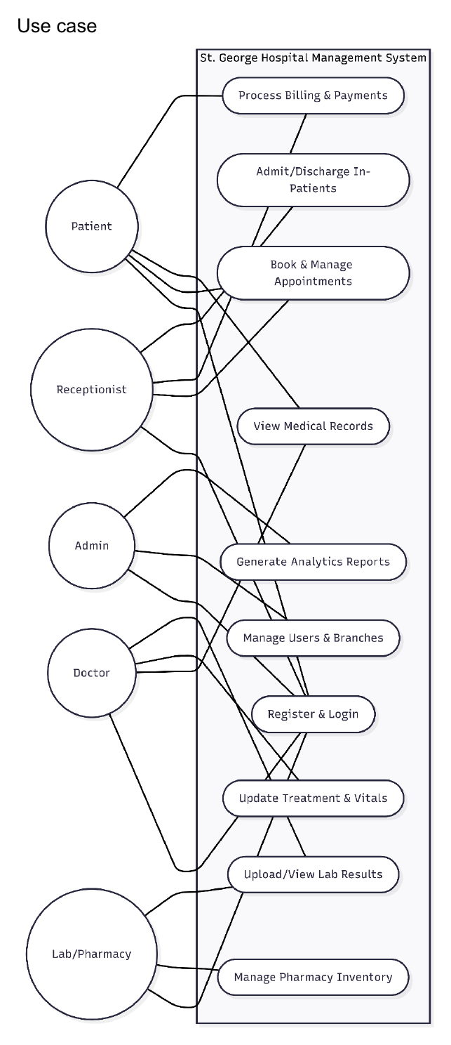
Figure F1. Supplied use-case diagram (draft; missing roles noted in Section 3).

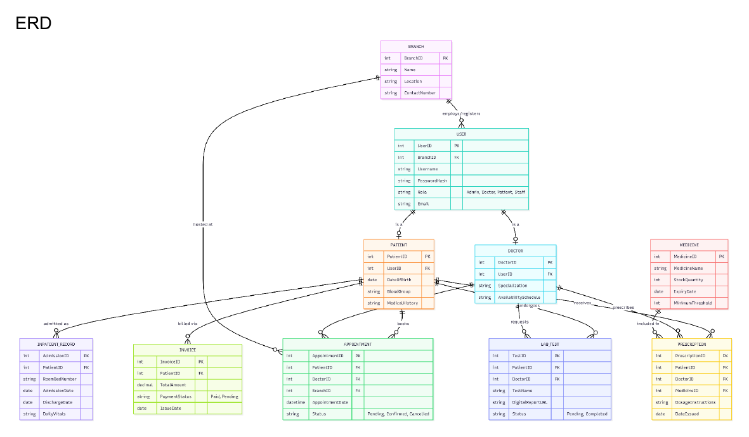
Figure F2. Supplied core entity-relationship diagram.

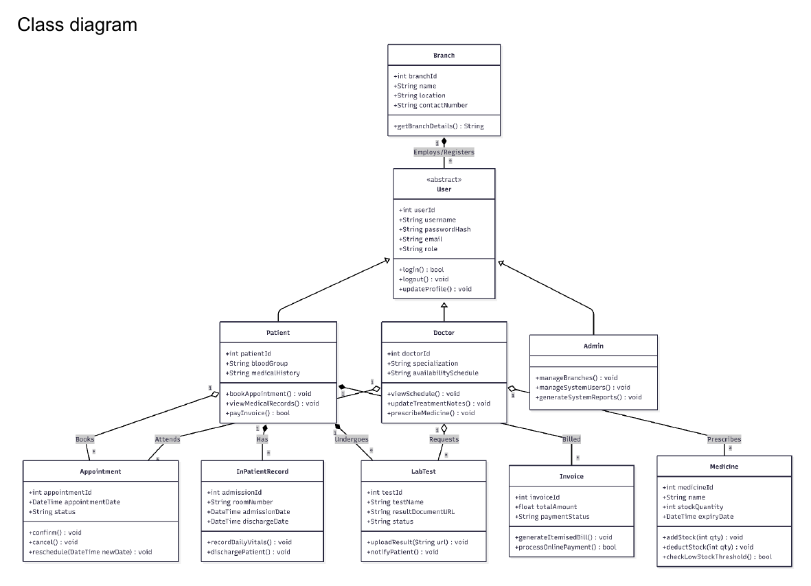
Figure F3. Supplied class diagram for the core object model.

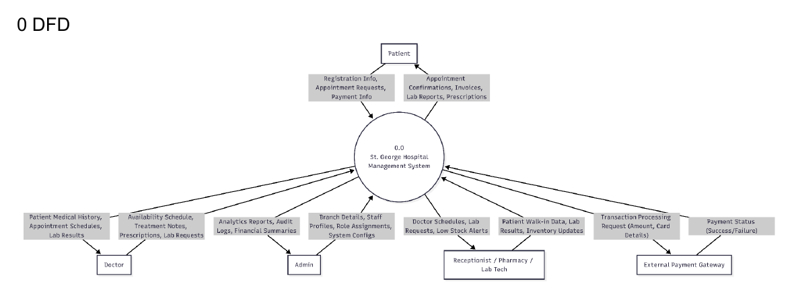
Figure F4. Level 0 data-flow diagram.

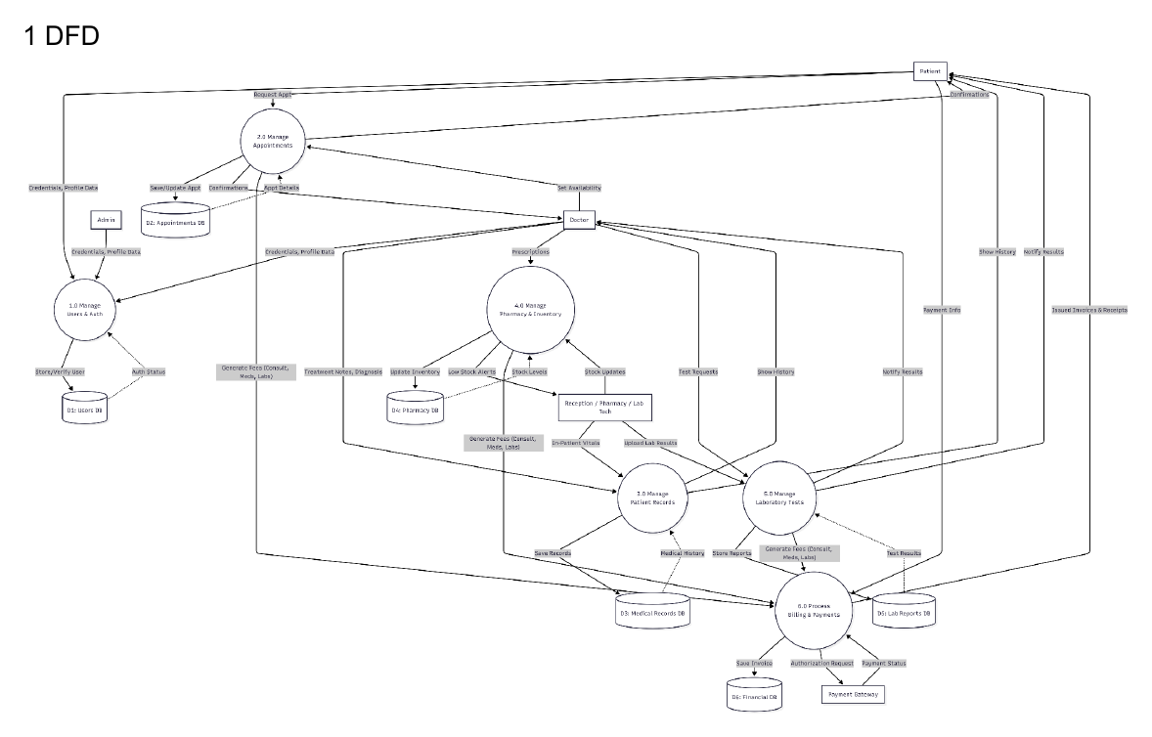
Figure F5. Level 1 data-flow diagram (redraw required for final readability).

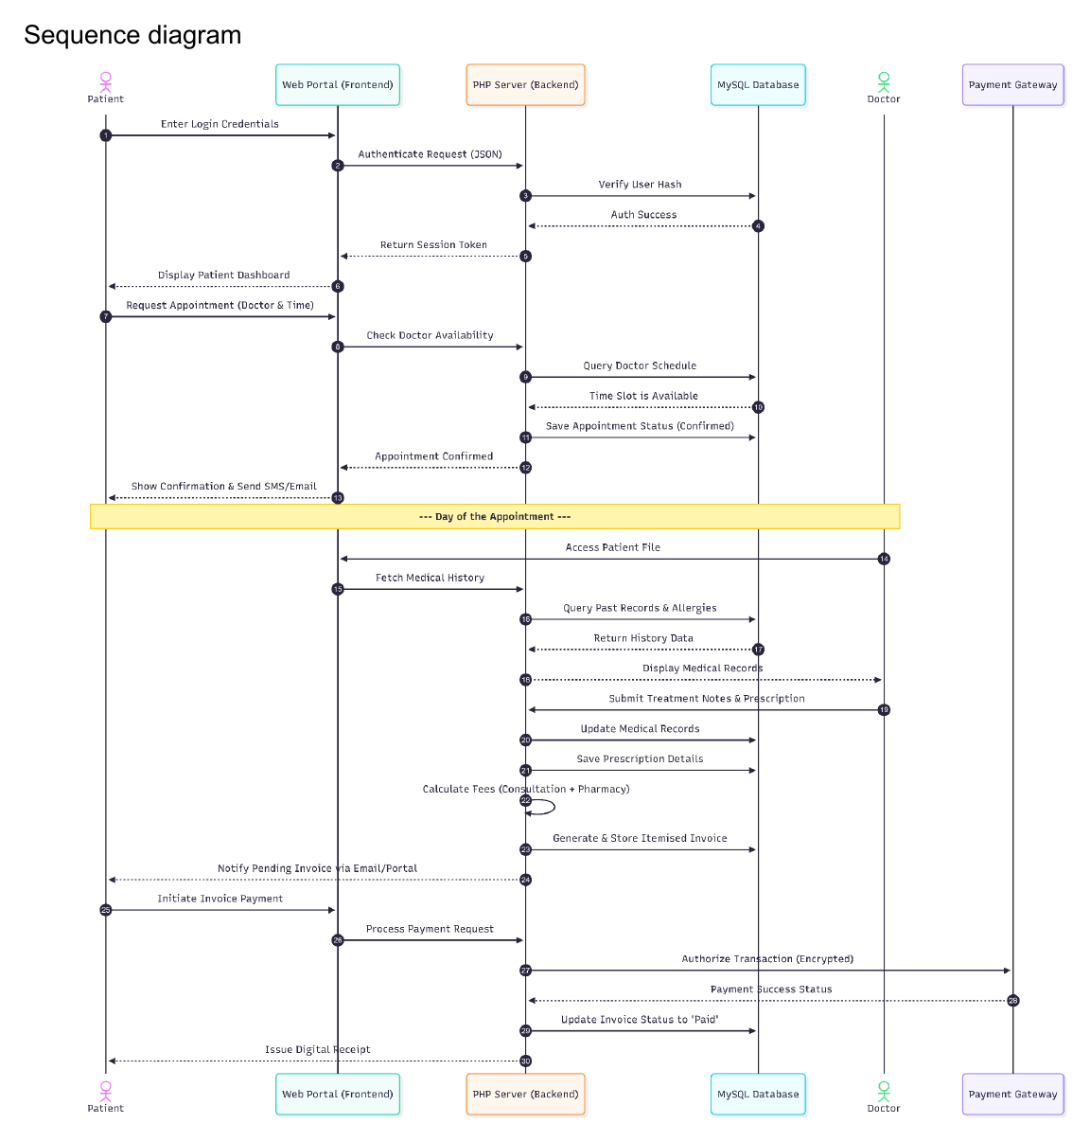
Figure F6. Supplied end-to-end sequence draft.

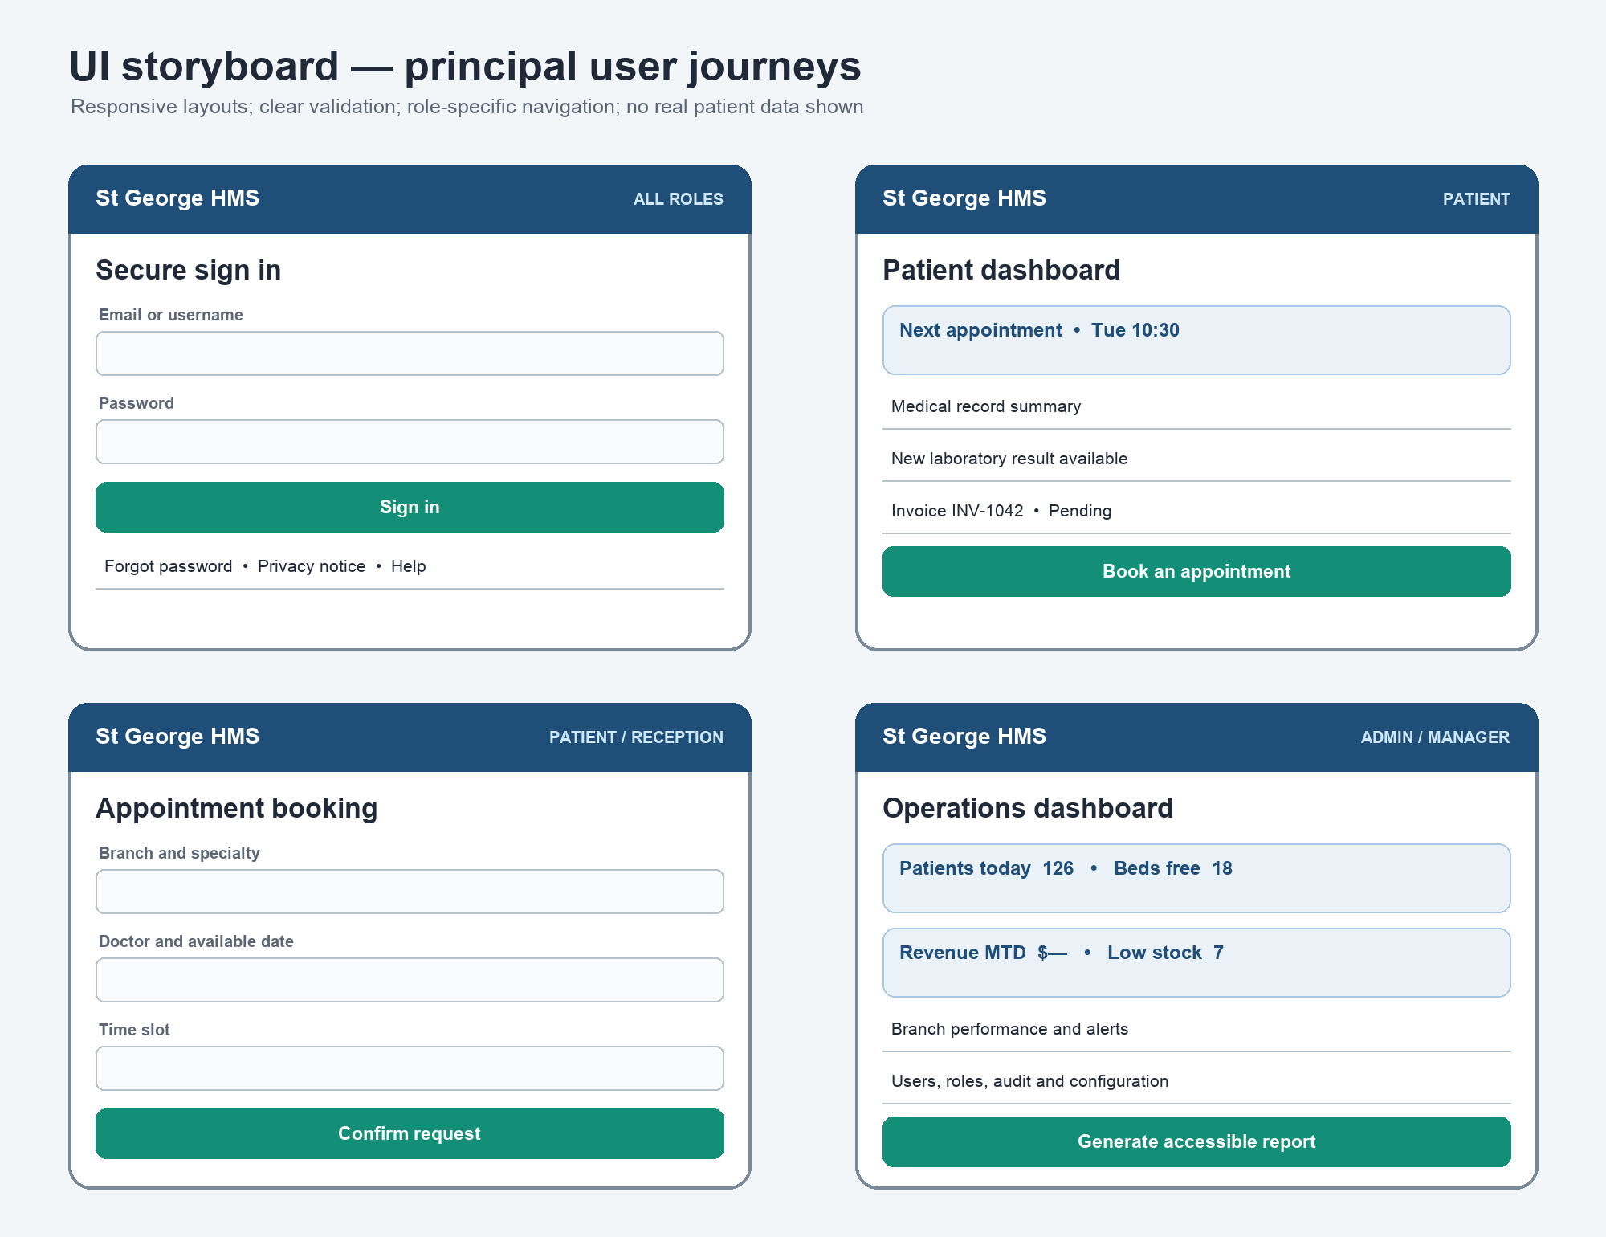
Figure F7. Proposed UI storyboard for principal user journeys.

Appendix G — Individual contribution statement
Evidence rule: Replace every placeholder with real links and dates. Each member should have assigned work, end-of-iteration commits/output, peer review and progress against an iteration objective.

Member | Assigned deliverables | Trello / GitHub / Drive evidence | Peer review | Completion
Priya Paneru | Schedule, scope, risks, decisions, submission | https://trello.com/c/priya-scope-decisions | Reviewed by Usha Tamang | 100% Completed
Usha Tamang | Requirements, traceability, use cases, DFD | https://trello.com/c/usha-traceability-dfd | Reviewed by Manish Das | 100% Completed
Manish Das | PHP/API, database, deployment/security | https://trello.com/c/manish-api-db | Reviewed by Oyndrila Oyshi Saha | 100% Completed
Oyndrila Oyshi Saha | UI/UX, accessibility, frontend | https://trello.com/c/oyndrila-ui-frontend | Reviewed by Krishala Niroula | 100% Completed
Krishala Niroula | Test cases, defects, regression/UAT | https://trello.com/c/krishala-tests-defects | Reviewed by Priya Paneru | 100% Completed

Required forum links
- Iteration plan link(s): https://lms.kent.edu.au/forums/cpro306-g3-iteration-plan
- Iteration report/review link(s): https://lms.kent.edu.au/forums/cpro306-g3-iteration-report
- Week 3 objectives versus actual progress: Completed Node.js/SQLite MVP, passed all 12 integration tests, finalized SRS layout and trace matrix.
- Lecturer feedback log/minutes: https://lms.kent.edu.au/forums/cpro306-g3-feedback-log

